Can you guess the name of the songs from the given lyrics?
- I’m bulletproof, nothing to lose
Fire away fire away
Ricochet you take your aim
Fire away fire away ……….

- When I find myself in times of trouble mother Mary comes to me
Speaking words of wisdom let it be ….

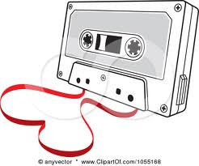
- But you didn’t have to cut me off
Make it like it never happened and that we were nothing
And I didn’t even need your love
But you treat me like a stranger and I feel so rough….

- Never mind I’ll find someone like you
I wish nothing but the best for you two
Don’t forget me, I begged, I remember you said
Sometimes it lasts in love but sometimes it hurts instead….

- That summer seemed to last forever
And if I had the choice, yeah I’d always wanna be there
Those were the best days of my life….

- When I see your face, there’s not a thing that I would change
Coz you’re amazing…

- Would it be the same? If I saw you in heaven?
I must be strong, and carry on
Coz I know I don’t belong, here in heaven….

- So shine bright, tonight
You and I, we’re beautiful like diamonds in the sky….

- Don’t’ make it bad
Take a sad song, and make it better
Remember to let her into your heart, and then you can start to make it better…

- You may say I’m a dreamer, but I’m not the only one
I hope someday you will join us, and the world will be as one….
