Pre Writing Worksheet
- List three instruments which you enjoy:
  - ___________________________________________
  - ___________________________________________
  - ___________________________________________
- Which of those three instruments do you like the most? ___________________________________________
- Is it a string instrument, wind instrument, or other instrument?
___________________________________________
- List 3 people who play this instrument
  - ___________________________________________
  - ___________________________________________
  - ___________________________________________
- Who is your favorite musician? ___________________________________________________________________________________________________________________________________________________________________________________________________________________________________________________________________________________________________
- Do you have a favorite music group? If Yes, who and why? __________________________________________________________________________________________________________________________________________________________________________________________________________________________________________________________________
- Can you give an example of a song which features this instrument?
  - Title: ___________________________________________
  - Artist: ___________________________________________
- When was the first time you heard this instrument? ___________________________________________________________________________________________________________________________________________________________________________________________________________________________________________________________________________________________________________________________________________________________________________________________________
- Would you learn how to play this instrument if you knew a teacher?
  - ________________________________________________________________________________________________________________________________________________________________________________________________________________________________________________________________________________________________
- Do people play this instrument in the country which you came from? ___________________________________________________________________________________________________________________________________________________________________________________________________________________________________________________________________________________________________
- Why is this your favorite instrument? ____________________________________________________________________________________________________________________________________________________________________________________________________________________________________________________________________________________________________________________________________________________________________________________________________
- What is your least favorite instrument? ___________________________________________________________________________________________________________________________________________________________________________________________________________________________________________________________________________________________________

Name:_____________________________________________ Date:_____________________________________
My Favorite Instrument
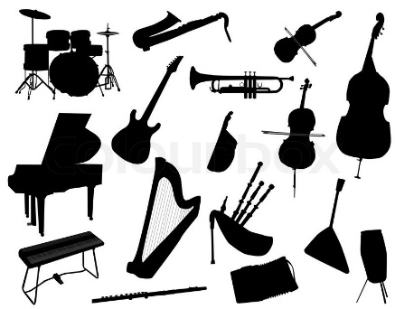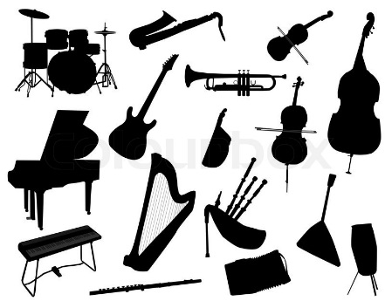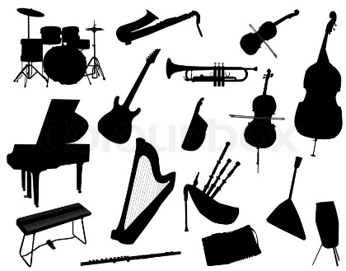
What is your favorite musical instrument? Why is it your favorite? Do you have a favorite musician who play this instrument? If yes, who is it. Would you play this instrument if you could? Tell us all about your favorite instrument using the pre-writing worksheet as your guide!
__________________________________________________________________________________________________________________________________________________________________________________________________________________________________________________________________________________________________________________________________________________________________________________________________________________________________________________________________________________________________________________________________________________________________________________________________________________________________________________________________________________________________________________________________________________________________________________________________________________________________________________________________________________________________________________________________________________________________________________________________________________________________________________________________________________________________________________________________________________________________________________________________________________________________________________________________________________________________________________________________________________________________________________________________________________________________________________________________________________________________________________________________________________________________________________________________________________________________________________________________________________________________________________________________________________________________________________________________________________________________________________________________________________________________________________________________________________________________________________________________________________________________________________________________________________________________________________________________________________________________________________________________________________________________________________________________________________________________________________________________________________________________________________________________________________________________________________________________________________________________________________________________________________________________________________________________________________________________________________________________________________________________________________________________________________________________________________________________________________________________________________________________________________________________________________________________________________________________________________________________________________________________________________________________________________________________________________________________________________________________________________________________________________________________________________________________________________________________________________________________________________________________________________________________________________________________________________________________________________________________________________________________________________________________________________________________________________________________________________________________________________________________________________________________________________________________________________________________________________________________________________________________________________________________________________________________________________________________________________________________________________________________________________________________________________________________________________________________________________________________________________________________________________________________________

